Teacher Job Description 2023
REFERENCE ONLY – PLEASE DO NOT FILL IN

Name:

Reg Status: Full

Exp Date:

Job Title: Teacher - fixed term

Section 1: School Goals (Our Code)

Section 2: Teacher Responsibilities (Our Standards)

Section 3: Specific Responsibilities

Section 1

School Goals

Professional | Baseline
Purpose | Uphold and promote the beliefs within our school:  Our mission of Empowering for Life- Kia Whakamana Kia Toa and our values of being Safe, Together, Achieving and Respectful
Knowledge | Has professional knowledge of key documents; School Charter, (Strategic Plan & Annual Plan) and School Curriculum.  Supporting documents: NELP, Ka Hikitia, Tātaiako, Te Takanga O Te Wā, Teaching for Positive Behaviour, Learning Support Delivery Model and Teaching to the North East.  Teaching competency in all Curriculum subject areas using the School (NZ) Curriculum.
Relationships | Positive and constructive relationships with staff and students  We role model what it is to be a good adult by;  - Managing self responsibly and reliably  - Relating to others with respect and friendliness  - Thinking with integrity and being proactive & self-reflective  - Participating and contributing appropriately  - Using professional and appropriate language
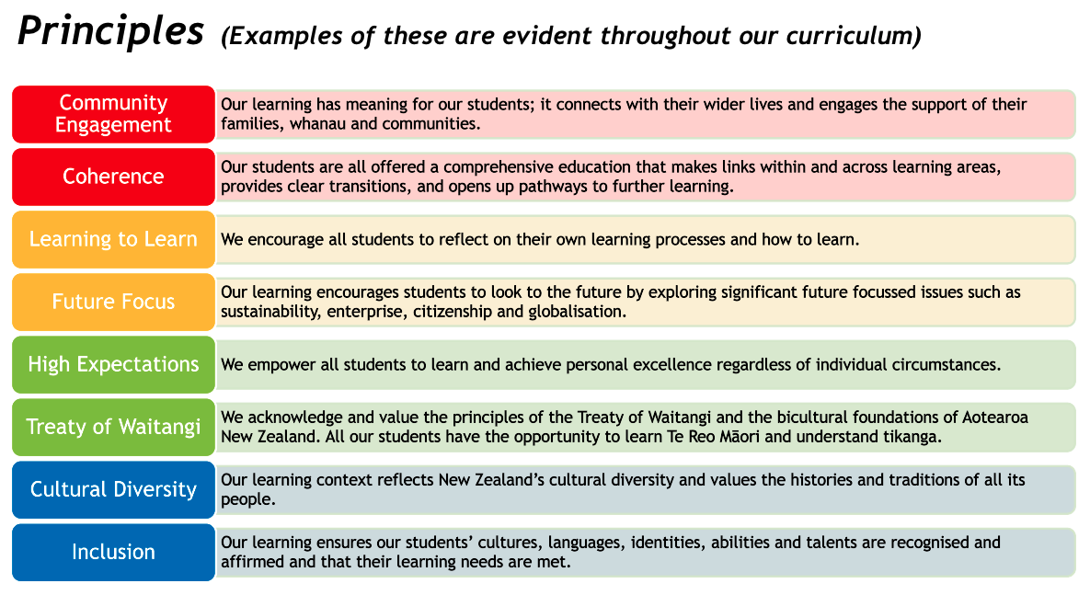

Section 2
TEACHER RESPONSIBILITIES

#1 Te Tiriti o Waitangi partnership  Demonstrate commitment to tangata whenuatanga and Te Tiriti of Waitangi partnership in Aotearoa New Zealand.  Tangata Whenuatanga:  Affirms Maori learners as Maori - provides contexts for learning where the identity, language and culture of Maori learners and their whanau is affirmed. | - Understand and recognise the unique status of tangata whenua in Aotearoa New Zealand.  - Understand and acknowledge the histories, heritages, languages and cultures of partners to Te Tiriti o Waitangi.  - Practice and develop the use of te reo and tikanga Maori.
#2 Professional Learning  Use inquiry, collaborative problem-solving and professional learning to improve professional capability to impact on the learning and achievement of all learners.  Ako:  Takes responsibility for their own learning and that of Maori learners. | - Inquire into and reflect on the effectiveness of practice in an ongoing way, using evidence from a range of sources.  - Critically examine how my own assumptions and beliefs, including cultural beliefs, impact on practice and the achievement of learners with different abilities and needs, backgrounds, genders, identities, languages and cultures.  - Engage in professional learning and adaptively apply this learning in practice.  - Be informed by research and innovations related to: content disciplines; pedagogy; teaching for diverse learners, including learners with disabilities and learning support needs; and wider education matters.  - Seek and respond to feedback from learners, colleagues and other education professionals, and engage in collaborative problem solving and learning-focused collegial discussions.
#3 Professional Relationships  Establish and maintain professional relationships and behaviours focused on the learning and wellbeing of each learner.  Whanaungatanga: Actively engages in respectful working relationships with Maori learners, parents and whanau, hapu, iwi, and the Maori community. | - Engage in reciprocal, collaborative learning focused relationships with:  - learners, families and whanau  - teaching colleagues, support staff and other professionals  - agencies, groups and individuals in the community  - Communicate effectively with others.  - Actively contribute, and work collegially, in the pursuit of improving my own and organisational practice, showing leadership, particularly in areas of responsibility.  - Communicate clear and accurate assessment for learning and achievement information.
#4 Learning-focused Culture  Develop a culture that is focused on learning, and is characterised by respect, inclusion, empathy, collaboration and safety.  Manaakitanga: Demonstrates integrity, sincerity, and respect towards Maori beliefs, language and culture. | - Develop learning-focused relationships with learners, enabling them to be active participants in the process of learning, sharing ownership and responsibility for learning.  - Foster trust, respect and cooperation with and among learners so that they experience an environment in which it is safe to take risks.  - Demonstrate high expectations for the learning outcomes of all learners, including those learners with disabilities or learning support needs.  - Manage the learning setting to ensure access to learning for all and to maximise learners’ physical, social, cultural and emotional safety  - Create an environment where learners can be confident in their identities, languages, cultures and abilities.  - Develop an environment where the diversity and uniqueness of all learners are accepted and valued.  - Meet relevant regulatory, statutory and professional requirements.
#5 Design for Learning  Design learning based on curriculum and pedagogical knowledge, assessment information and an understanding of each learner’s strengths, interests, needs, identities, languages and cultures.  Wananga:  Participates with learners and communities in robust dialogue for the benefit of Maori learners. | - Select teaching approaches, resources, and learning and assessment activities based on a thorough knowledge of curriculum content, pedagogy, progressions in learning and the learners.  - Gather, analyse and use appropriate assessment information, identifying progress and needs of learners to design clear next steps in learning and to identify additional supports or adaptations that may be required.  - Design and plan culturally responsive, evidence-based approaches that reflect the local community and Te Tiriti o Waitangi partnership in New Zealand.  - Harness the rich capital that learners bring by providing culturally responsive and engaging contexts for learners.  - Design learning that is informed by national policies and priorities.
#6 Teaching  Teach and respond to learners in a knowledgeable and adaptive way to progress their learning at an appropriate depth and pace.  Ako:  Takes responsibility for their own learning and that of Maori learners. | - Teach in ways that ensure all learners are making sufficient progress, and monitor the extent and pace of learning, focusing on equity and excellence for all.  - Specifically support the educational aspirations for Maori learners, taking shared responsibility for these learners to achieve educational success as Maori.  - Use an increasing repertoire of teaching strategies, approaches, learning activities, technologies and assessment for learning strategies and modify these in response to the needs of individuals and groups of learners.  - Provide opportunities and support for learners to engage with, practice and apply learning to different contexts and make connections with prior learning.  - Teach in ways that enable learners to learn from one another, to collaborate, to self-regulate and to develop agency over their learning.  - Ensure learners receive ongoing feedback and assessment information and support them to use this information to guide further learning.

SECTION 3

SPECIFIC RESPONSIBILITIES (including unit holders)

Responsibility | Descriptor

Signed |  | Signed
Principal | Date | Teacher | Date

